- EXAMPLE WITH OPTION AUTO_CREATE_STATISTICS

ALTER DATABASE [AdventureWorks] SET AUTO_CREATE_STATISTICS OFF WITH NO_WAIT
GO

select * into teste1 from sys.objects;
select * into teste2 from sys.objects;

create clustered index pk_t1 on teste1(object_id);
create clustered index pk_t1 on teste2(object_id);

select *from teste1;
select *from teste2;

select a.name from teste1 a, teste2 b where a.name=b.name

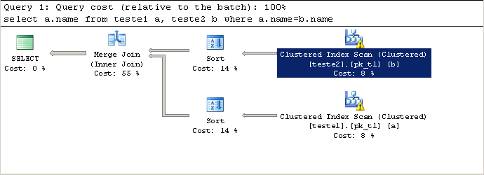

drop table teste1;
drop table teste2;

ALTER DATABASE [AdventureWorks] SET AUTO_CREATE_STATISTICS ON WITH NO_WAIT
GO

select * into teste1 from sys.objects;
select * into teste2 from sys.objects;

create clustered index pk_t1 on teste1(object_id);
create clustered index pk_t1 on teste2(object_id);

select *from teste1;
select *from teste2;

select a.name from teste1 a, teste2 b where a.name=b.name

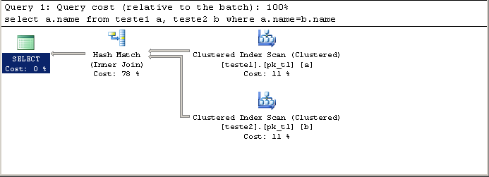

ALTER DATABASE [AdventureWorks] SET AUTO_CREATE_STATISTICS OFF WITH NO_WAIT
GO

drop table teste1;
drop table teste2;

select * into teste1 from sys.objects;
select * into teste2 from sys.objects;

create clustered index pk_t1 on teste1(object_id);
create clustered index pk_t1 on teste2(object_id);

select *from teste1;
select *from teste2;

select a.name from teste1 a, teste2 b where a.name=b.name

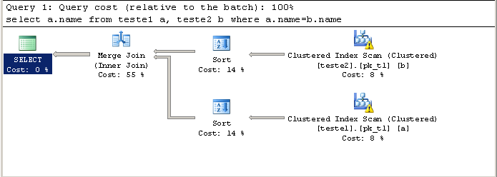

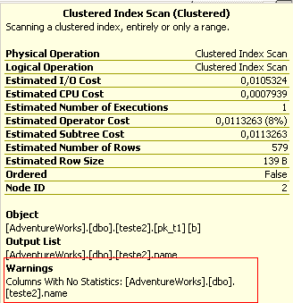 | 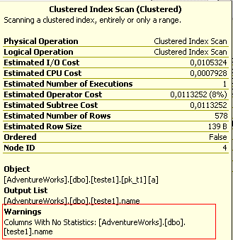

- EXAMPLE WITH OPTION AUTO_CREATE_STATISTICS II

USE [AdventureWorks]
GO
CREATE STATISTICS [statistics_teste1_Name] ON [dbo].[teste1]([name])
GO

USE [AdventureWorks]
GO
CREATE STATISTICS [statistics_teste1_Name] ON [dbo].[teste2]([name])
GO

select a.name from teste1 a, teste2 b where a.name=b.name
select a.name from teste1 a, teste2 b where a.name=b.name
select a.name from teste1 a, teste2 b where a.name=b.name
select a.name from teste1 a, teste2 b where a.name=b.name
select a.name from teste1 a, teste2 b where a.name=b.name
select a.name from teste1 a, teste2 b where a.name=b.name

The execution Plan keeps the same, as you can see:

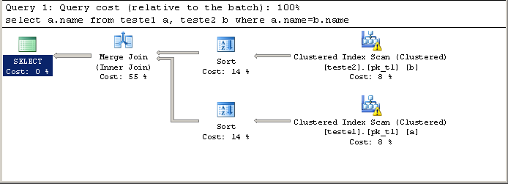

Now, I’m going to clear up the Plan cache with the following statement:

DBCC FREEPROCCACHE

select a.name from teste1 a, teste2 b where a.name=b.name

Now, the execution Plan has considerated the new statistics created :

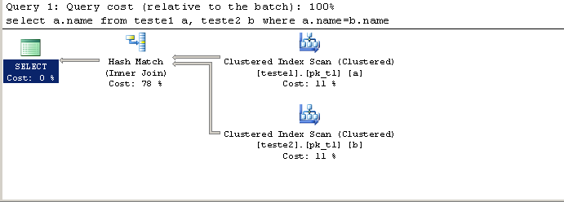

You can notice that the result of execution plan with the statements (ALTER DATABASE [AdventureWorks)…) and CREATE STATISTICS are the same.

